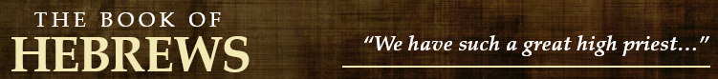
9.1-10
- What were the “regulations for worship” and the “earthly place of holiness”?

- Contrast the “first section” and the “second section” of the temple.

9.11-14
- When and where did Christ appear as a high priest?

- How did he enter?

- In doing so, what did he secure?

- What happens after the purification of our conscience from dead works?

9.15-22
- Be prepared to discuss the following concepts as explained in this section:

  - Covenant
  - Promises
  - Inheritance
  - Will
  - Death
  - Blood
  - Forgiveness
9.23-28

- How were the copies of the “heavenly things” purified?

- How are the “heavenly things” purified?

- What is one thing that Christ is actively doing in heaven?

- What was Christ’s primary purpose in coming?

- What will be Christ’s purpose in his second coming?

