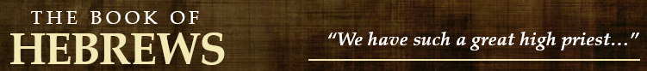
10.1-4
- What can the law never do? (vs. 1,4)

- Old covenant sacrifices bring what to remembrance? (vs. 3)

10.5-14
- What did God not desire or take any pleasure in? (vs. 5-6)

- What was prepared? (vs. 5)

- For what purpose was it prepared? (vs. 7, 10)

- Contrast the frequency of old covenant sacrifices to Christ’s sacrifice. (vs. 11-14)

10.15-18
Take note of this abridged repeat of Hebrews 8.8-12 where he quotes from Jeremiah 31. He is restating for emphasis.

10.19-25
- What two things does the author say, “since we have….”? (vs. 19,21)

- As a result, three times the author says, “let us…” do what? (vs. 22-24)

10.26-31
- To whom is the stern warning directed? (vs. 26)

- What argument does the author make about the punishment deserved by Christians who continue deliberately sinning?

10.32-39
- In what ways does the author encourage his audience? (vs. 32-34)

- What did the audience need? (vs. 35-36)

- What must the righteous do and NOT do according to vs. 38-39?

