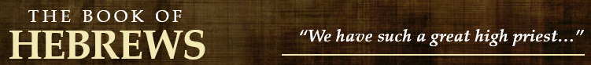
12.1-2
- Due to being “surrounded by so great a cloud of witnesses” what were they to lay aside? (vs. 1)

- What were they encouraged to do? (vs. 1-2)

- How is Jesus described? (vs. 2)

- What reason is given that allowed Jesus to endure the cross and what was the result? (vs. 2)

12.3-11
- If we “consider him”, what should be the result? (vs. 3-4)

- How should we view discipline? (vs. 5-9)

- What is God’s purpose in disciplining His children? (vs. 10-11)

12.12-17
- With a proper understanding of discipline, what are some things the author admonishes the Hebrews to do? (vs. 12-13)

- What does the text say about peace, holiness, and grace? (vs. 14-15)

- Who does the author use an example of “root of bitterness”, defilement, unholiness, and lifelong regrets? (vs. 15-17)

12.18-24
- Describe the scene/mood at Mt. Sinai. (vs. 18-21)

- How is Mt. Zion different? (vs. 22-24)

- How does Jesus’ blood “speak a better word” than Abel’s? (vs. 24)

12.25-29
- What is the danger in refusing this warning?

- What should we be grateful for that “cannot be shaken”? (vs. 27-28)

- As a result, what are we to offer? (vs. 28-29)

